
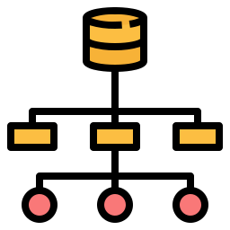
Internal Navigation System
Course Name: Data Structures

Student Names: Salem Dawani (ID#: 2410202), Mohammad Nairoukh (ID#2410205), Sanad Hosin (ID#2410148), and Aws Shubeil (ID#:2410024)
Instructor Name: Dr. Ola Al-Surakhi

Overview:
This program models an indoor navigation system for the SB building. It allows users to perform various actions, this includes searching for a specific office, adding a new office, removing an existing office, and traversing the building internal layout. The program is designed using a tree structure, with nodes representing separate office spaces and floors.
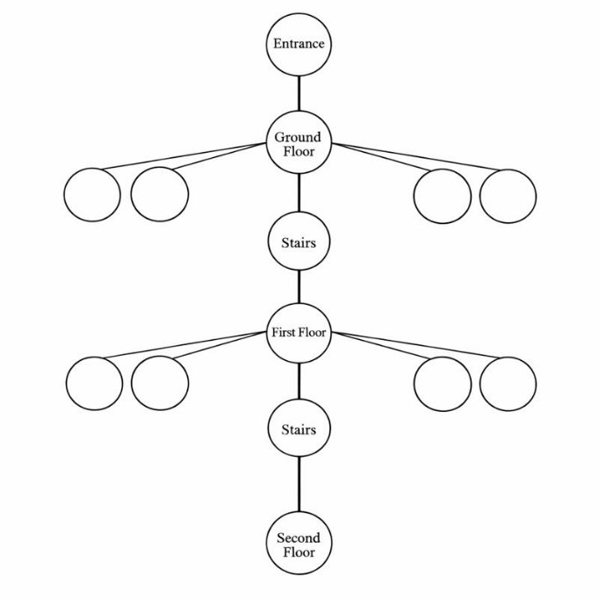

Implemented Operations:
- Description: This method enables the user to add/insert a new office room on the ground floor. It prompts the user to select the side on which the room should be inserted, either the left side or right side of the ground level. Using range based for loops, we are able to ensure that duplicate rooms, or rooms that already exist, are not added again. If no duplicate is found, a new node object is created using the user defined credentials and added to either the left or right child vector, depending on the user’s earlier selection. Upon successful insertion, a small message saying “insertion completed successfully” is displayed to the user on the screen.

- Description: This method enables the user to add/insert a new office room on the first floor. It prompts the user to select the side on which the room should be inserted, either the left side or right side of the first level. Using range based for loops, we are able to ensure that duplicate rooms, or rooms that already exist, are not added again. If no duplicate is found, a new node object is created using the user defined credentials and added to either the left or right child vector, depending on the user’s earlier selection. Upon successful insertion, a small message saying “insertion completed successfully” is displayed to the user on the screen.

- Description: This method enables the user to delete/remove an existing office room from the ground floor. It prompts the user to select the side from which the room should be deleted, either the left side or right side of the ground level. The method also prompts the user to enter the credentials of the office they wish to remove. If the user enters credentials for a nonexistent office room, a small message is displayed on the screen saying” the room you are trying to delete does not exist”. If the specified office credentials are found, the corresponding node object is deleted from either the left or right child vector. Upon successful deletion, a small message saying “deletion completed successfully” is displayed to the user on the screen.

- Description: This method enables the user to delete/remove an existing office room from the first floor. It prompts the user to select the side from which the room should be deleted, either the left side or right side of the first level. The method also prompts the user to enter the credentials of the office they wish to remove. If the user enters credentials for a nonexistent office room, a small message is displayed on the screen saying” the room you are trying to delete does not exist”. If the specified office credentials are found, the corresponding node object is deleted from either the left or right child vector. Upon successful deletion, a small message saying “deletion completed successfully” is displayed to the user on the screen.

- Description: This method traverses over the tree structure. It begins at the root node and proceeds in order to visit every branch of the tree, covering all child and leaf nodes. Such method requires the use of recursive calls, with the function itself getting repeatedly invoked itself as it moves from one node to the next.

- Description: this method allows the user to search for a specific office within the building. It prompts the user to enter the credentials of the office he is searching for. By using a helper function called recursivesearch, this method is able to display the path that must be followed to reach desired office location. One perk of this method is that if the user attempts to access the second floor, a small message is displayed on screen saying “Unauthorized Access: This Level Is Restricted to Authorized Personnel Only”. By using a string of vector alongside the recursivesearch method, the path to the desired office is built as the method traverses the tree structure.

- Description: this method works on the principle of recursive function calls. It takes the target room as a parameter, along with a string vector in which the path/route to the desired office is built. It traverses over the tree structure, starting at the root node and proceeds in order to visit every branch of the tree, covering all child and leaf nodes, in search of the target room. It returns true if the target room is located and false otherwise.

Screenshots:
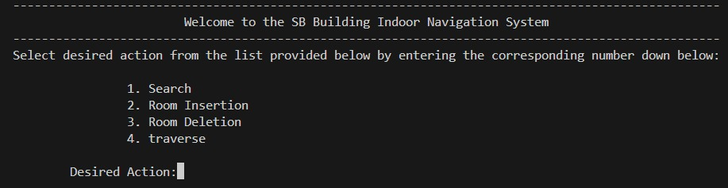
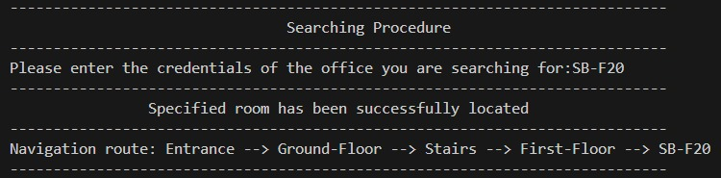
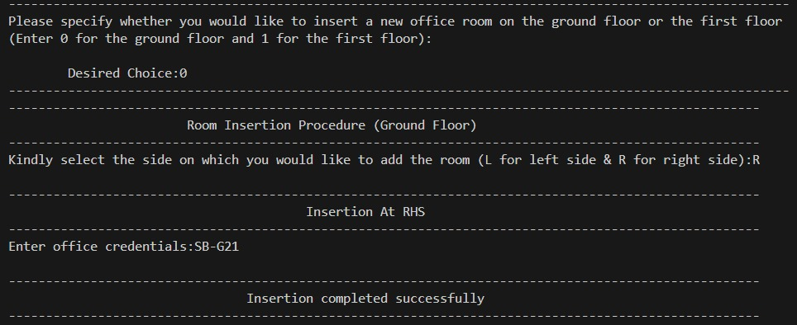
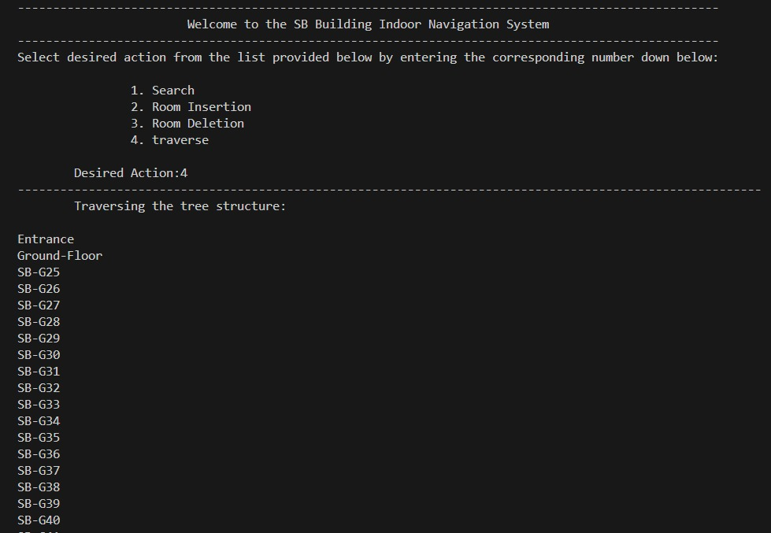
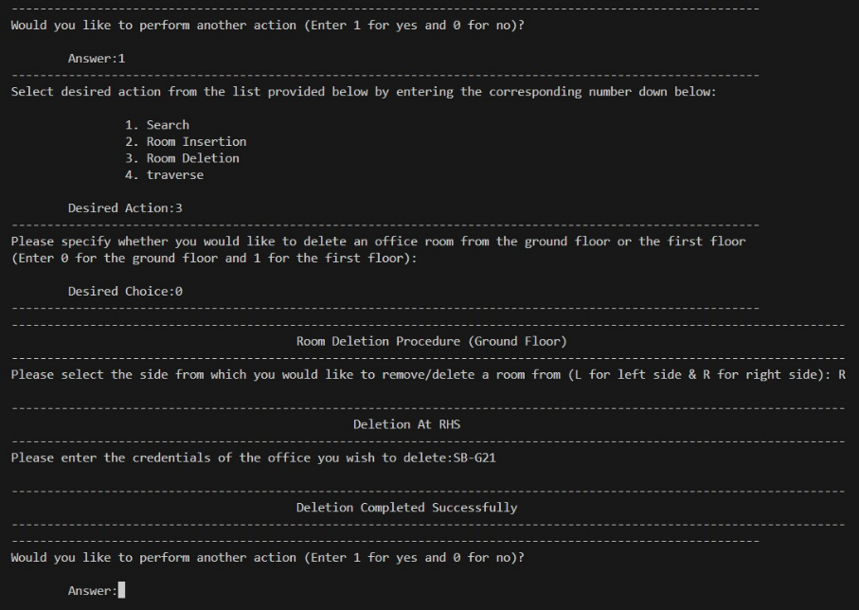
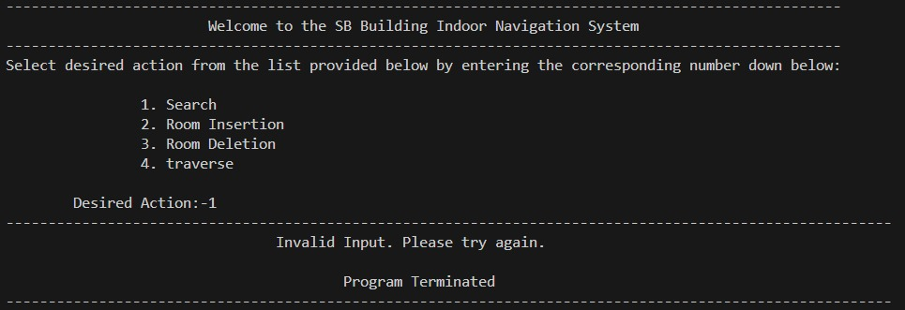
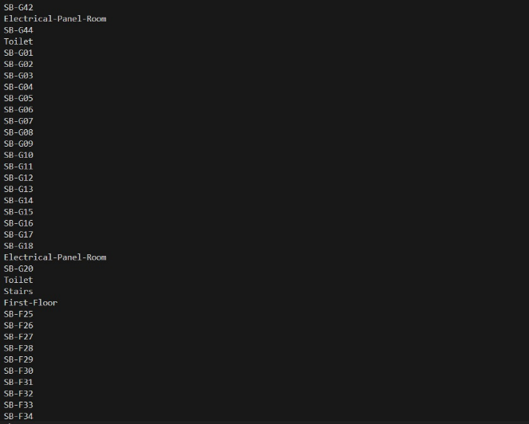

Conclusion:
In conclusion, we successfully developed a fully functional indoor navigation system using c++. The tree data structure served as the base of our project, with nodes representing different office spaces and floors. Along the way, we learned a lot, gained significant understanding of the data structure course, writing functional codes rather than solely understanding theoretical concepts.



